**Performed steps**

1. Open up simulation.
2. Insert variables.
3. Calculate with the same variables.
4. Compare results.

**Results**

This is the result with the simulation:

In realistic calculation when the input boat velocity is 10km/h.

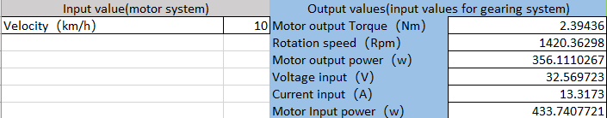

In theoretical calculation:

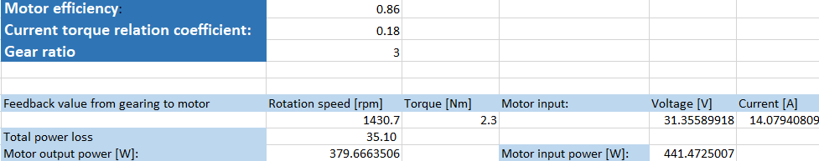

This is the result of the calculations:

$$P_{in}=\frac{P_{out}}{η}$$

$$T∝I$$

$$P=UI=\frac{TN}{9.55}$$

**Conclusion**

In conclusion, the outputs from the realistic calculation match the outputs from the theoretical calculation and data sheet. Therefore, the hypothesis:

*“the motor simulation has the same output as the calculations*”

is correct and the simulation works as intended.